**Resume** 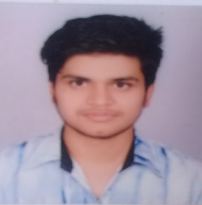

**Aashish Aryal**

***Kirtipur Kathmandu***

**Mobile: +9779867182424**

CAREER OBJECTIVE

To seek a challenging environment that encourages continuous learning and creativity provides exposure to new ideas and simulates personal and professional growth, also seeking a position to utilize my skill and ability.

PERSONAL DETAILS

*Date of birth: 2054/03/22*

*Fathers Name: Indra Mani Aryal*

*Gender: Male*

*Marital Status: Single*

*Permanent Address: Chandrakot-8, Turang, Gulmi*

*Religion: Hindu*

*Nationality: Nepali*

*Languages known: Nepali, English, Hindi*

*Hobbies: Reading articles, Travelling etc.*

ACADEMIC QUALIFICATION

|  |  |  |  |  |
| --- | --- | --- | --- | --- |
| No. | Academic Level | Name of  Institution | Percentage/ Score | Year of  Completion |
| 1. | S.L.C | Shree Gyanodhaya Higher S.School | 74.75% | 2070 |
| 2. | 10+2 | New Horizon College,Butwal | 66% | 2071/72 |
| 3. | Bachelor | Softwarica College of IT and E-commerce | Running(4th semi) | 2073/_ |

**Personal Interest**

* Hardware and maintenance
* Networking field

**Computer skills**

* *Word Processing, Power point, Excel, Data Analysis and Presentation, Email and Internet.*
* *Basic knowledge of Graphics Design*
* *Good in HTML, PHP, JavaScript, JQuery, MySQL, oracle*
* *Knowledge in CI frame work*
* *Fluent working in MVC design pattern*
* *Faster typing skill*

## ***Tools Skills***

* *Visual paradigm, MS visio, Star UML, FIGMA, Photoshop*

**Personal Strengths**:

-*Good interpersonal, excellent coordination and communication skills and ability to adopt in new environment quickly.*

*- Ability to work in team.*

*- Skills of proposal and report writing****.***

**References:**

Softwarica College of IT & E-Commerce, Kathmandu

New Horizon college, Butwal

Shree Gyanodhaya H.S School

***(I hereby solemnly affirm that the information contained herein is correct to the best of my knowledge. Any false Statement in this resume is a cause for my dismissal.)***